**GitHub** is one of the largest code host in the open source world which is basically a social networking site for the developers in the layman’s terms. GitHub is very advantageous for its social coding features as it provides a shared platform for all the developers to work upon a particular project.

The GitHub was released in April 2008 by Tom Preston-Werner, Chris Wanstrath, and PJ Hyett. The evolution of Github was due to several factors such as the Git platform was pretty desolate, finite and not designed up to the mark. In addition, it lacked commercial Git Hosting options hence GitHub was the advanced platform which had to be released.

I personally liked the idea of a common platform where developers can share their code, put in their inputs which increases the efficiency and the flexibility for the software development. These type of cloud services are very essential to the students also to collaborate with the sharp minds and work rigorously towards the social coding.

**GitHub Tutorial:**  
Git is a Distributed version control system used for software development. Following are the commands which we got acquainted to while performing the tutorial:

1)

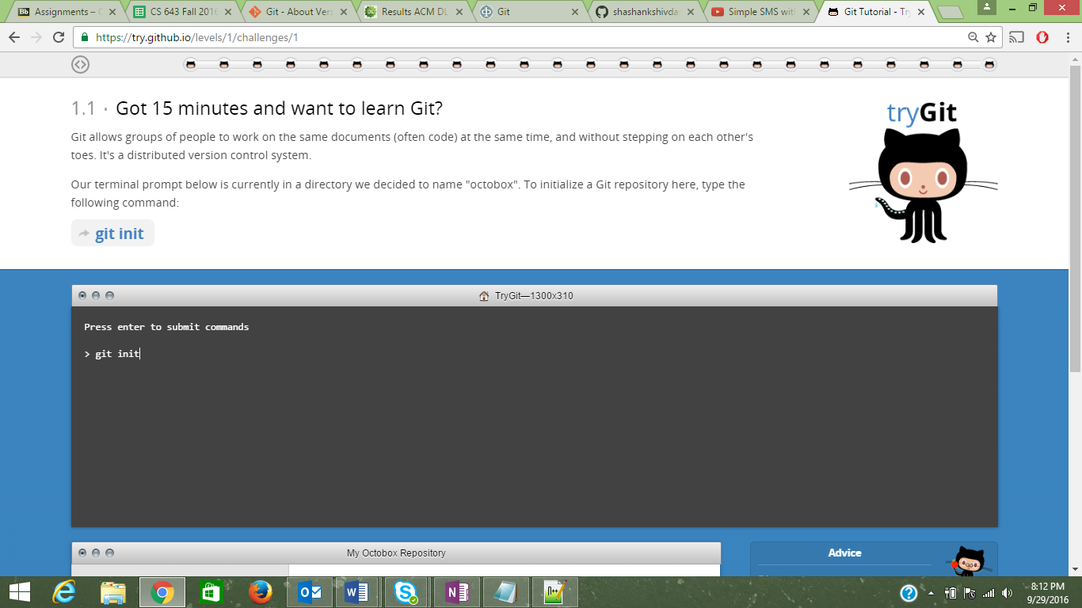

2)

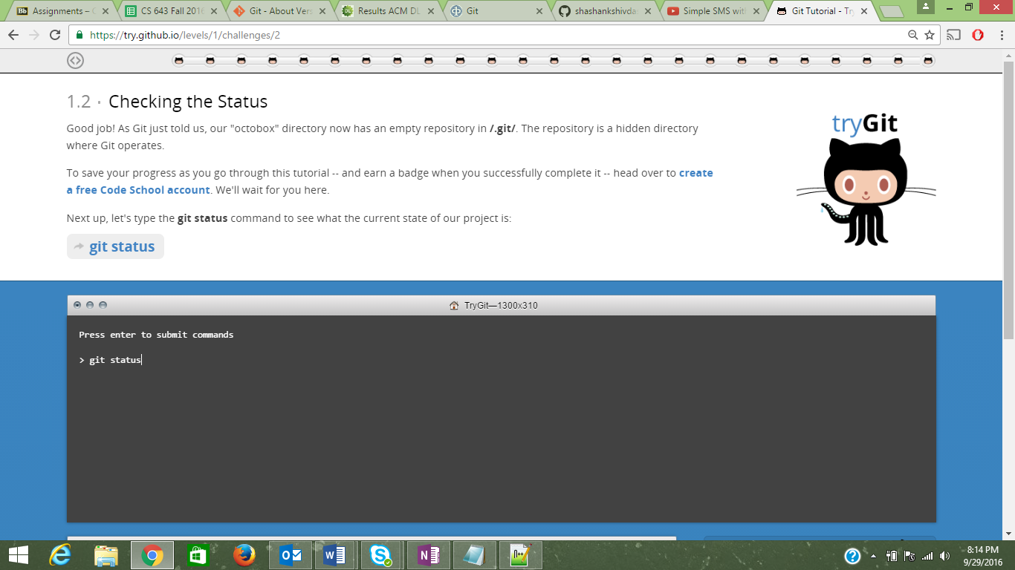

3)

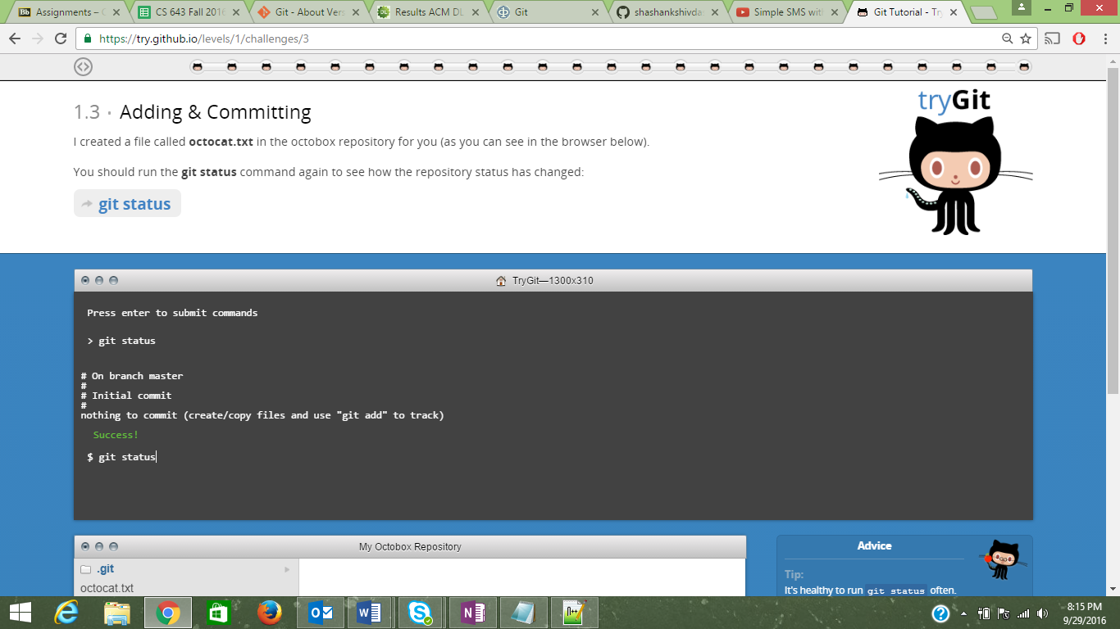

4)

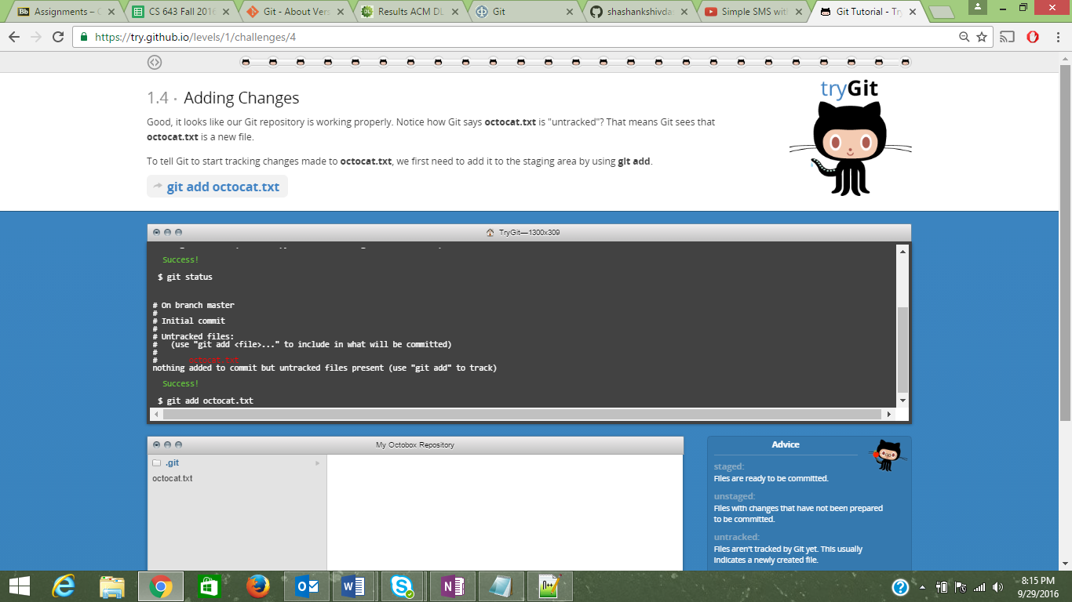

5)

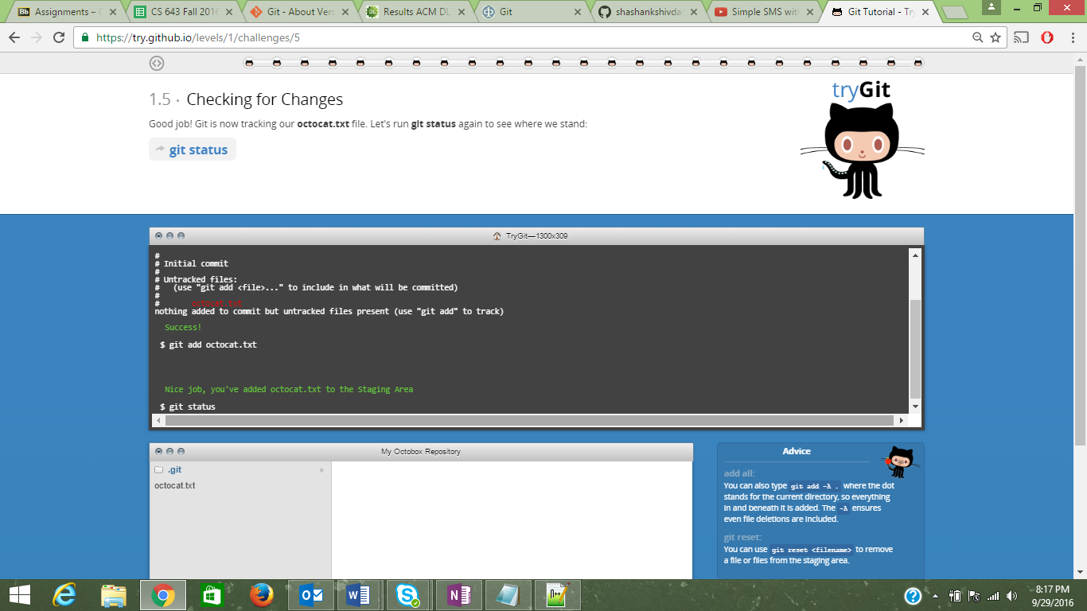

6)

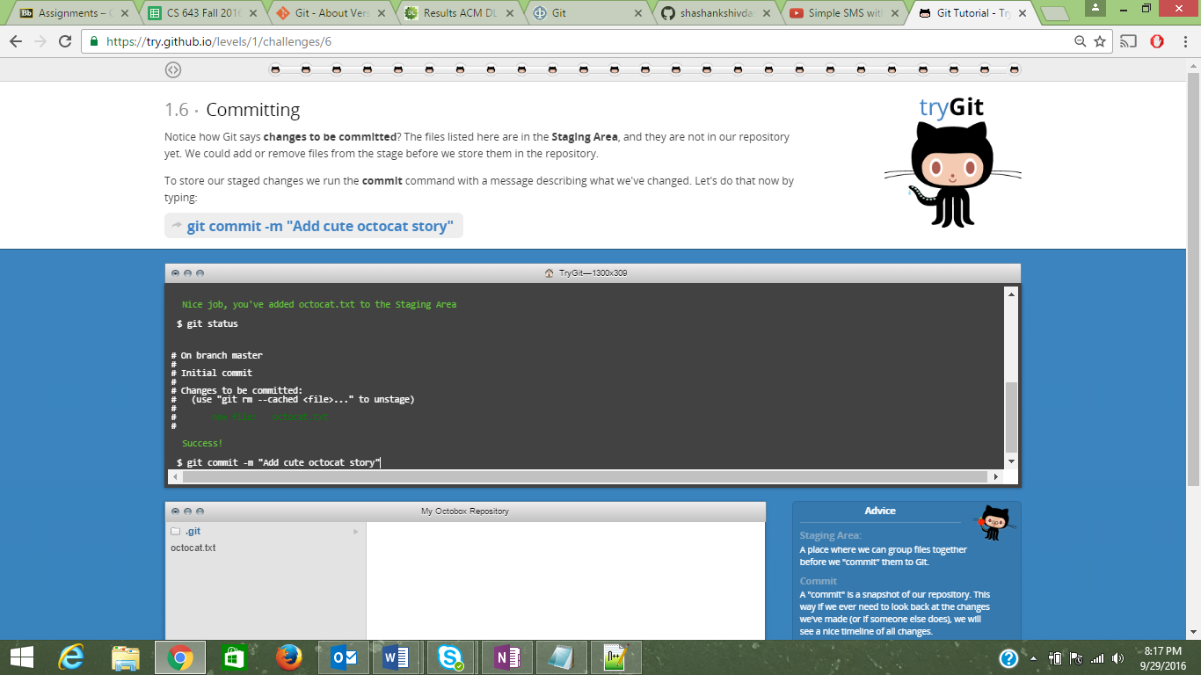

7)

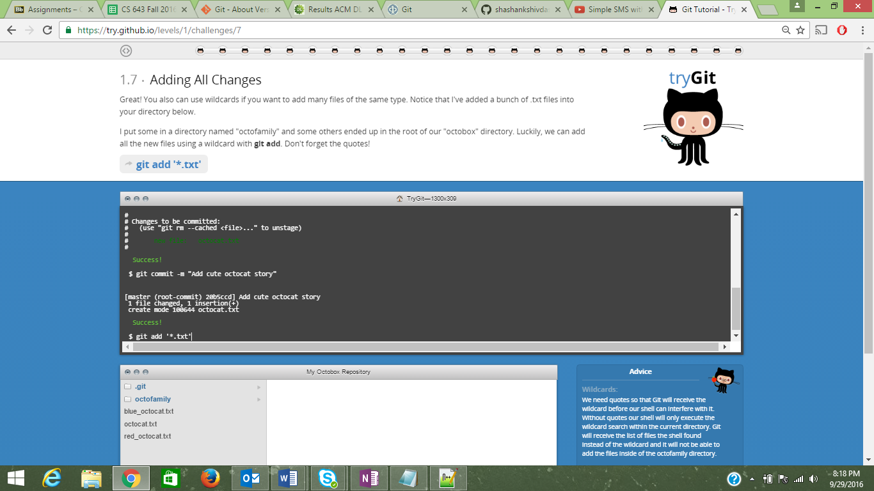

8)

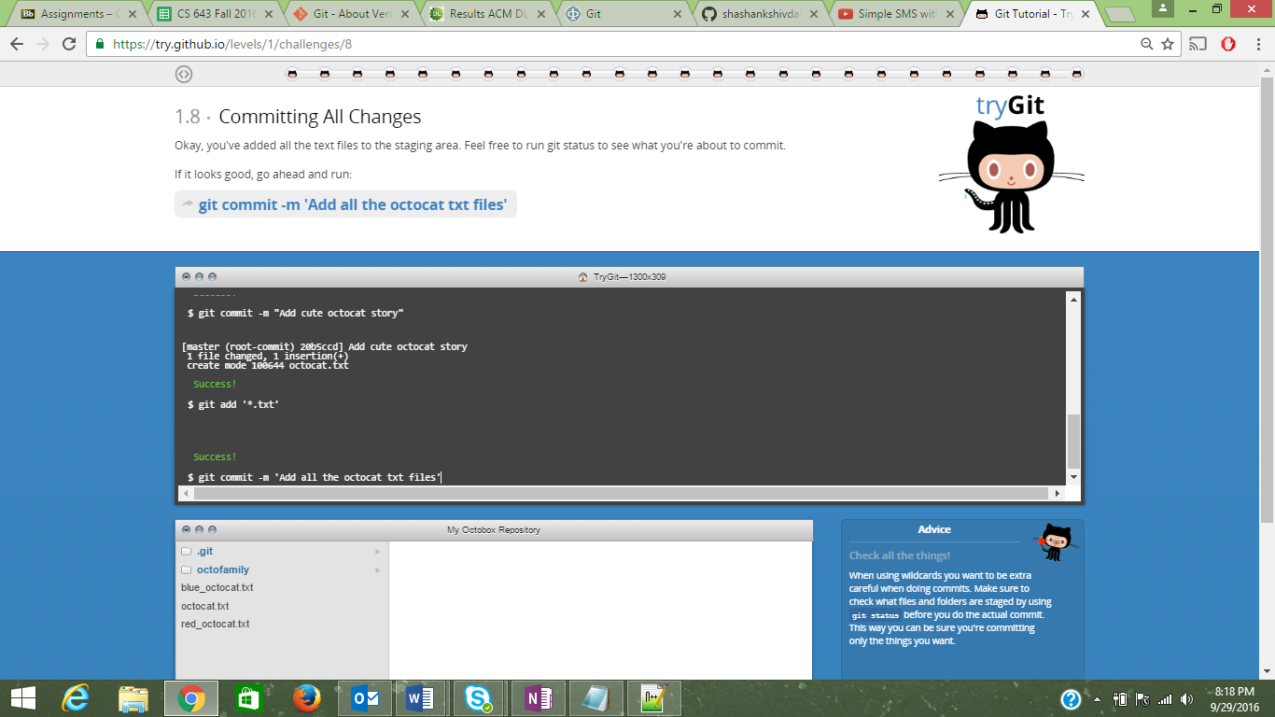

9)

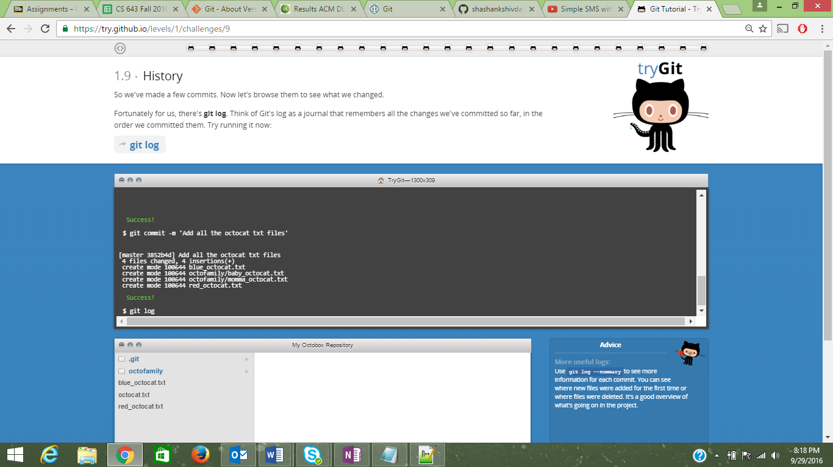

10)

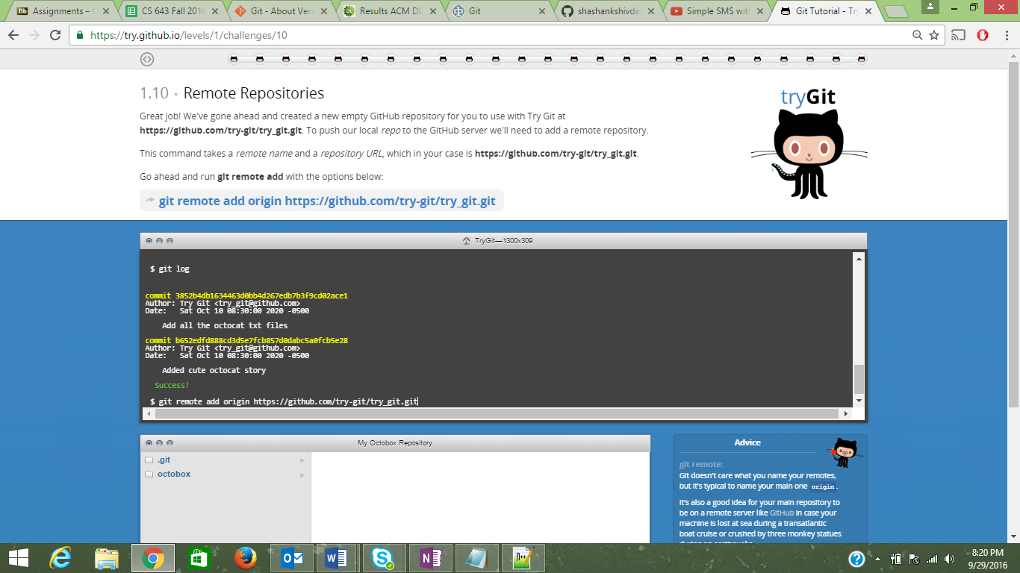

11)

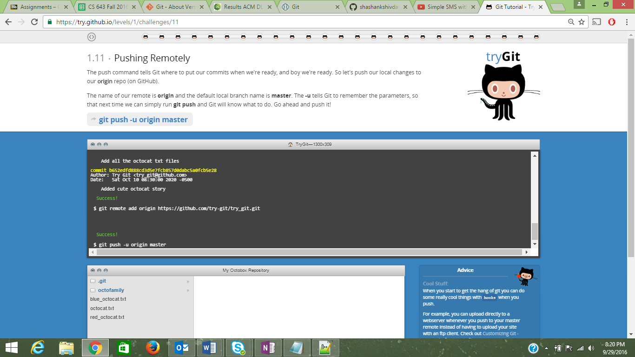

12)

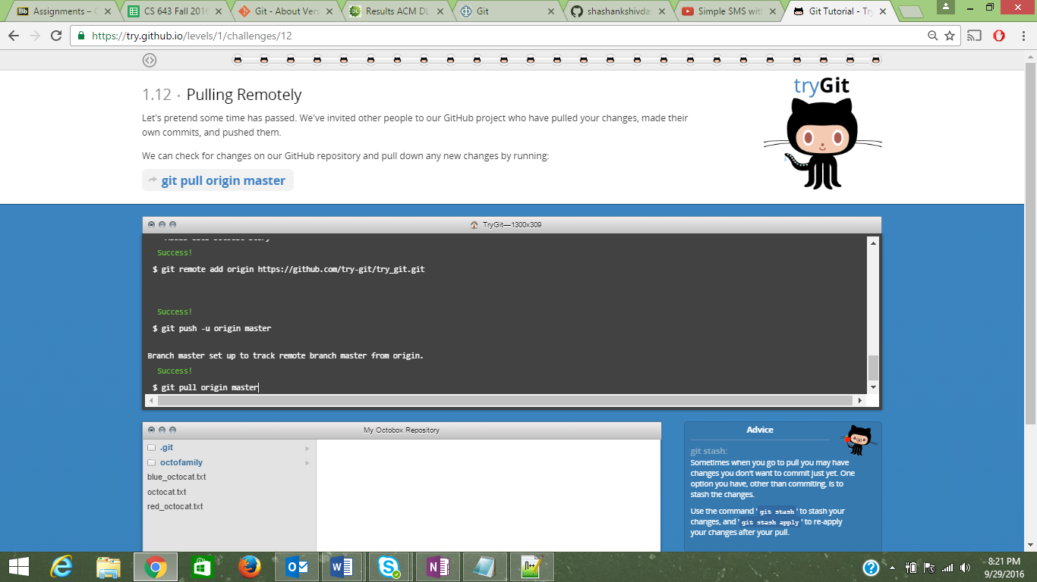

13)

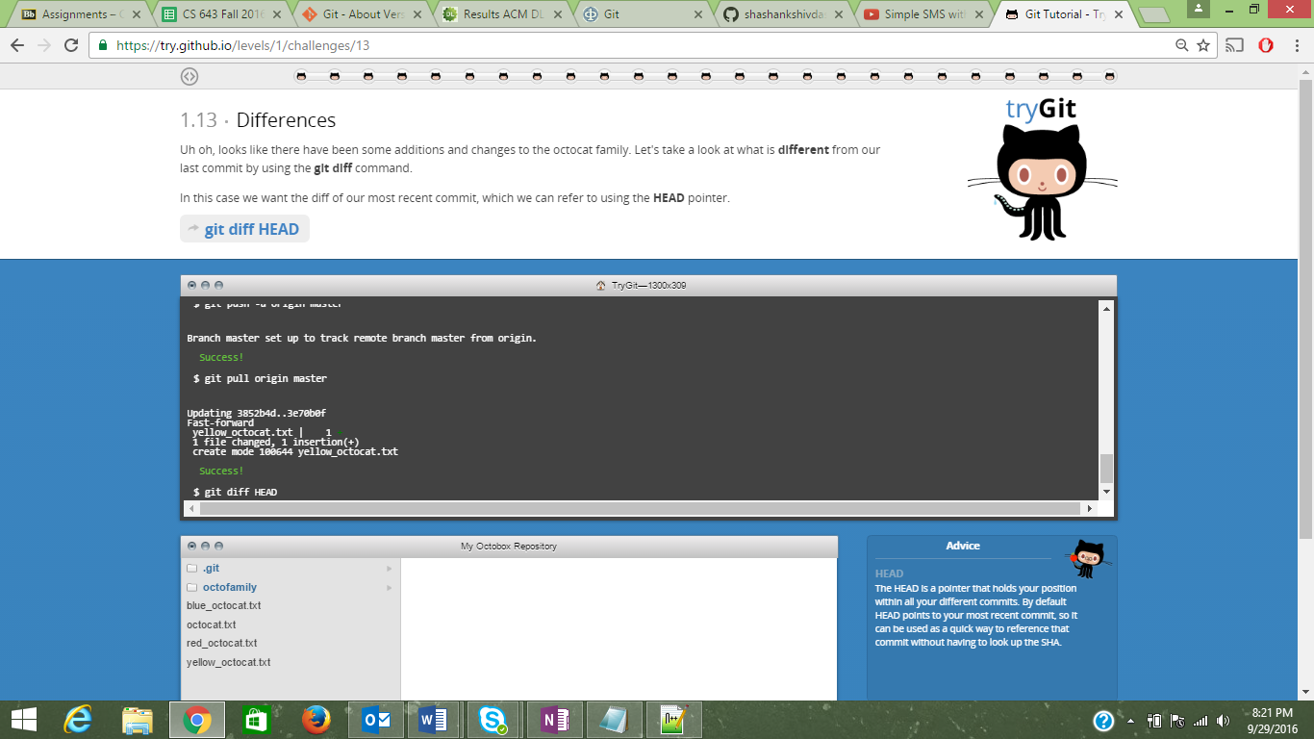

14)

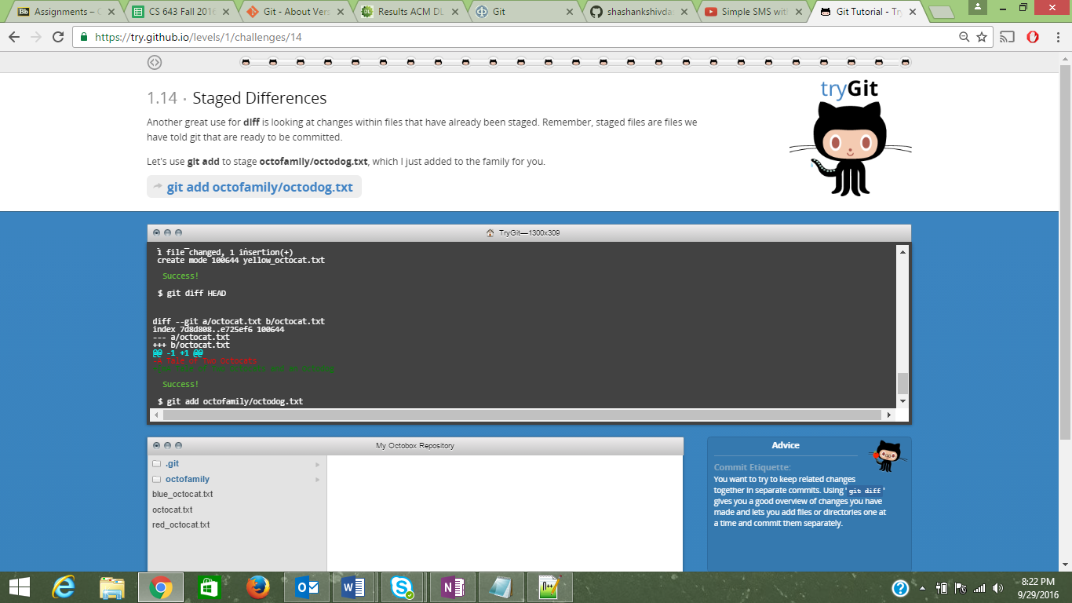

15)

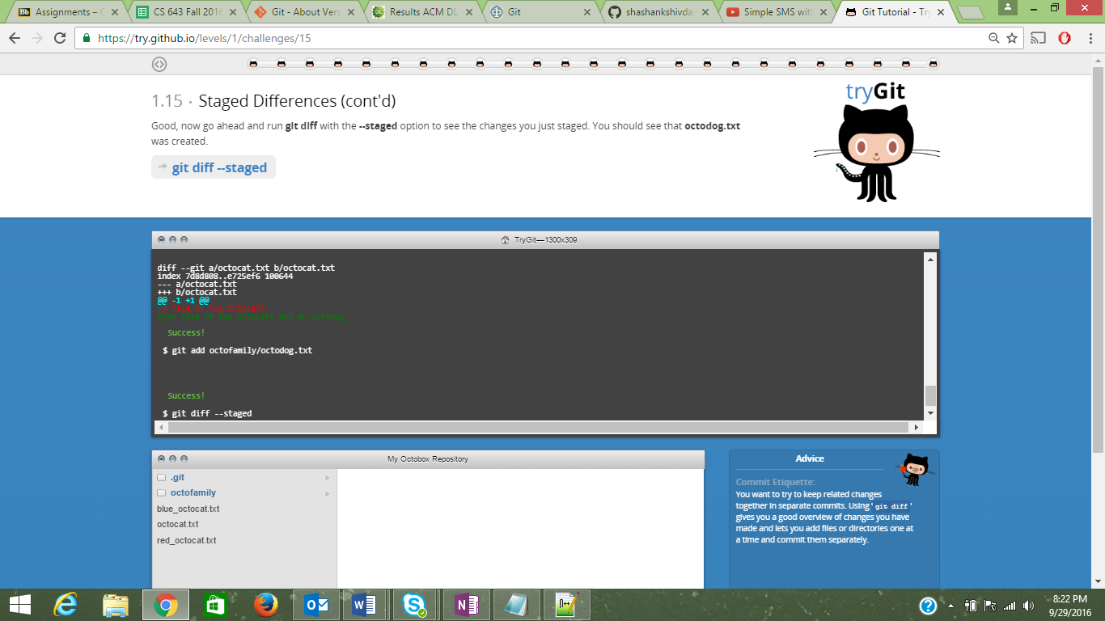

16)

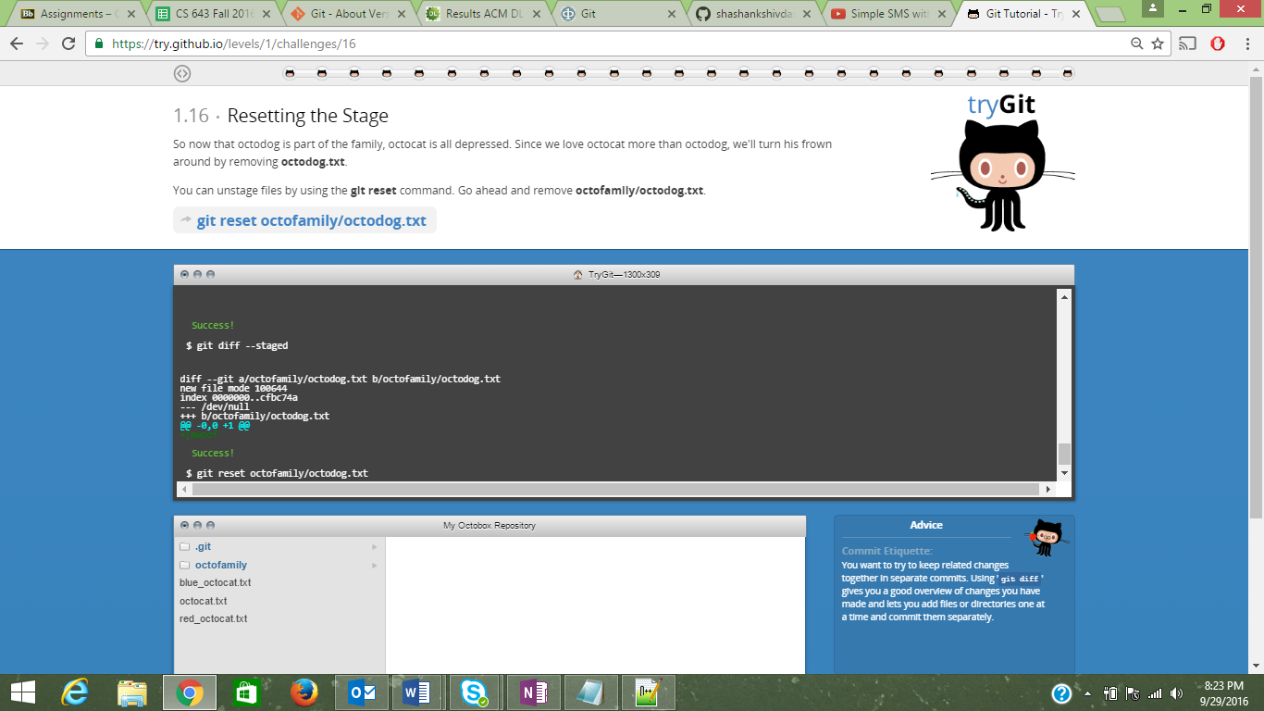

17)

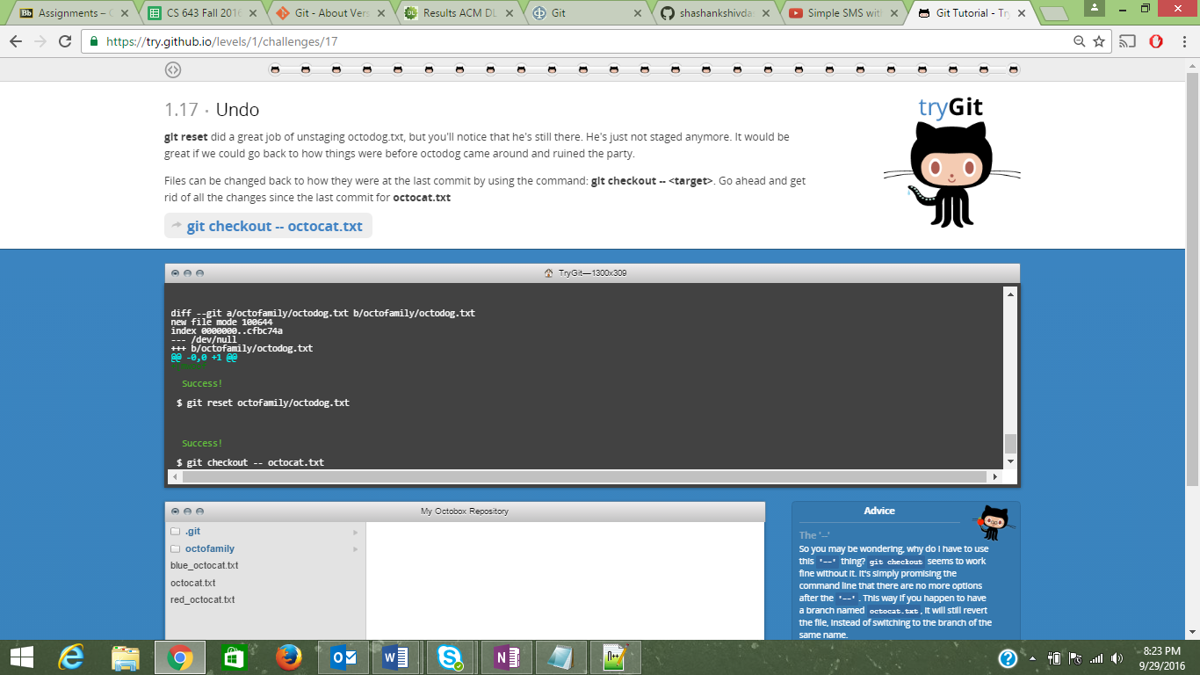

18)

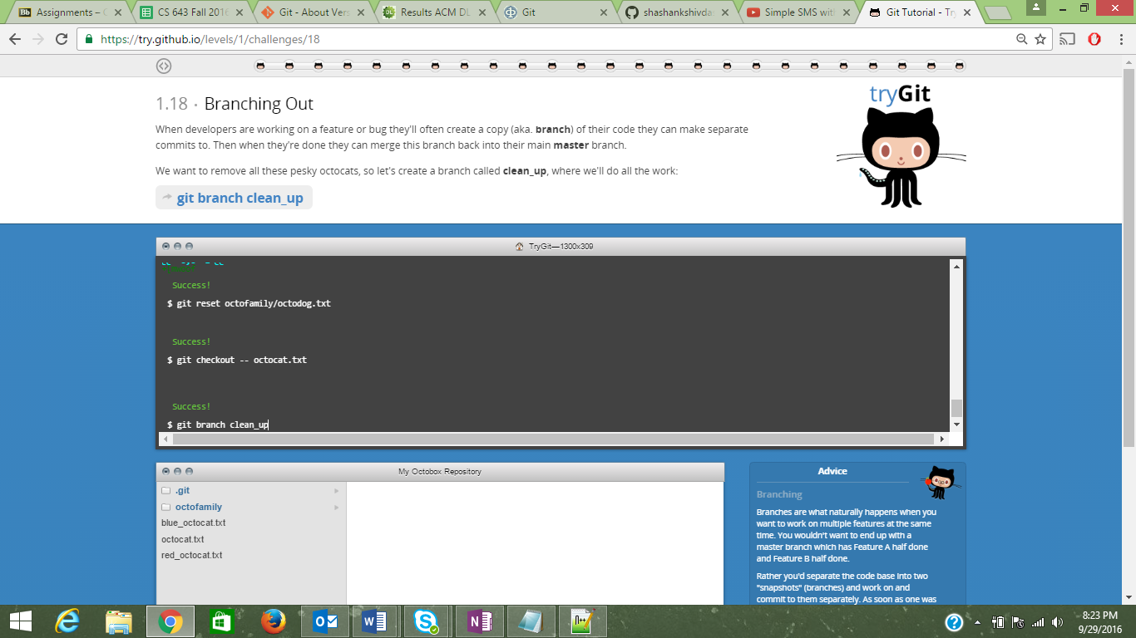

19)

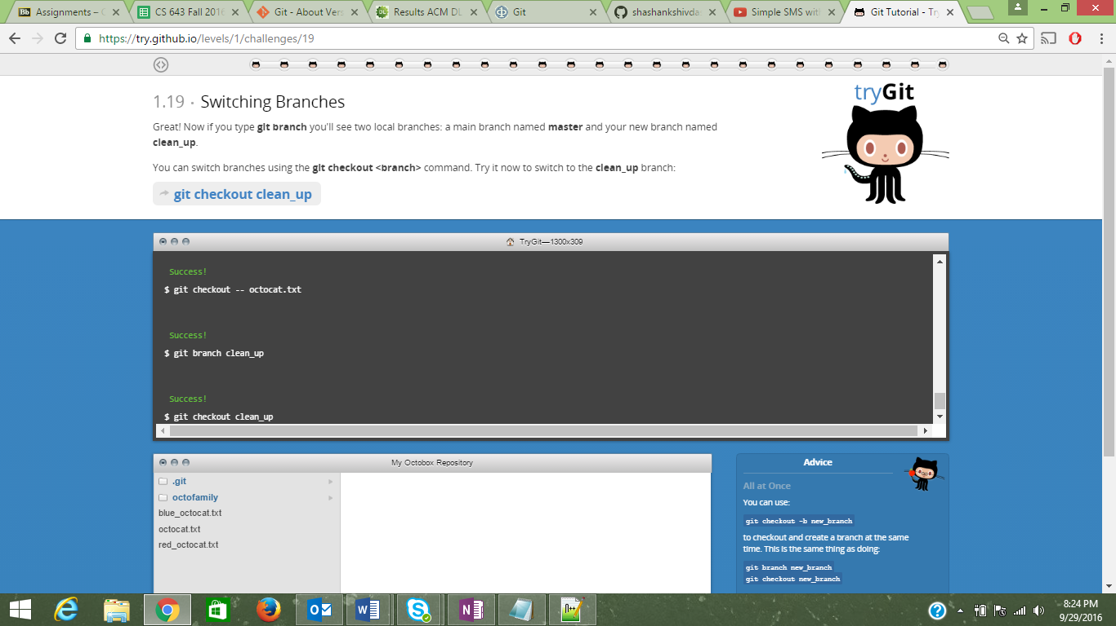

20)

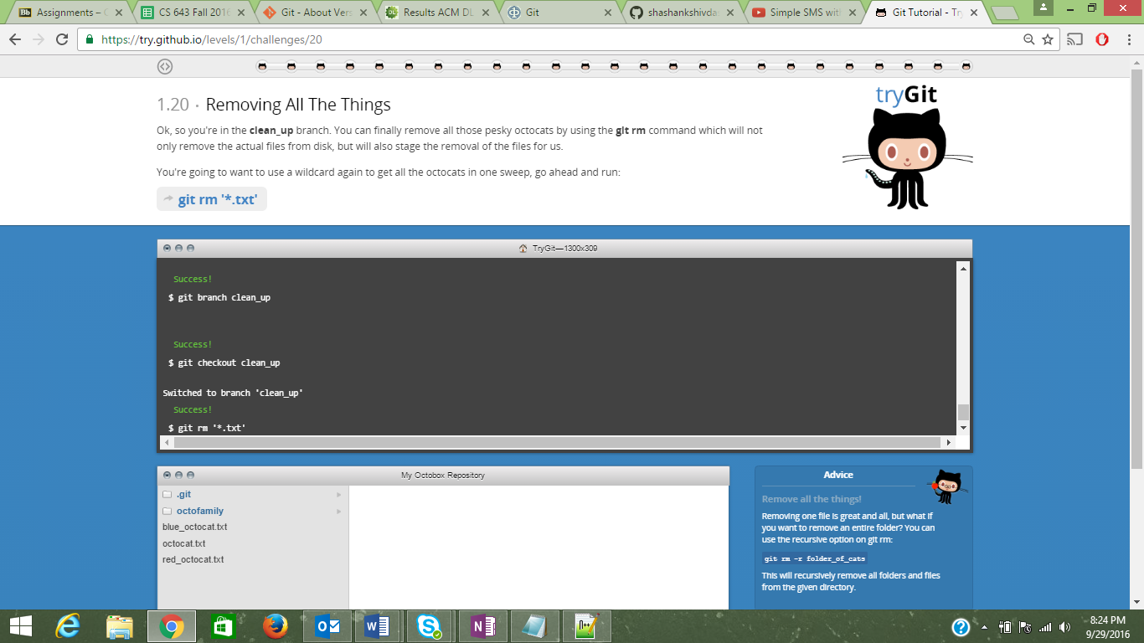

21)

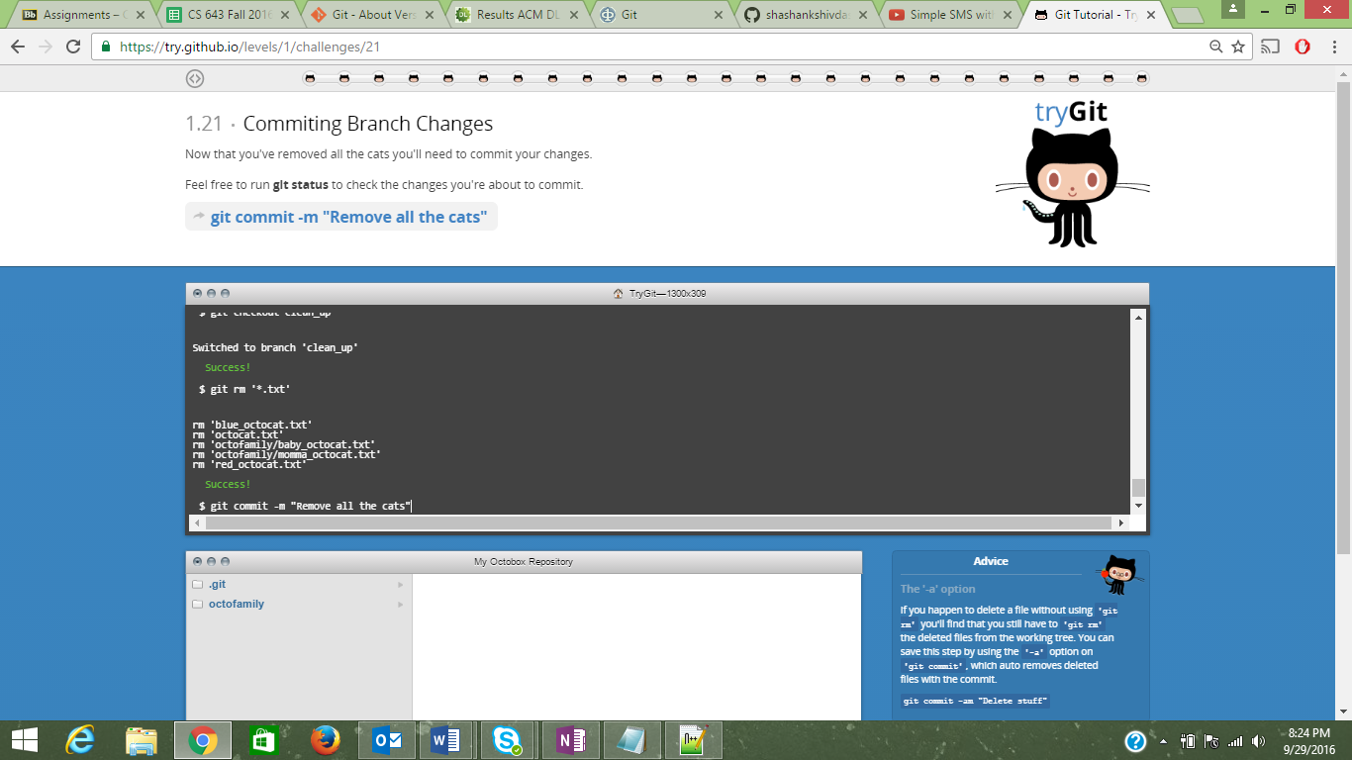

22)

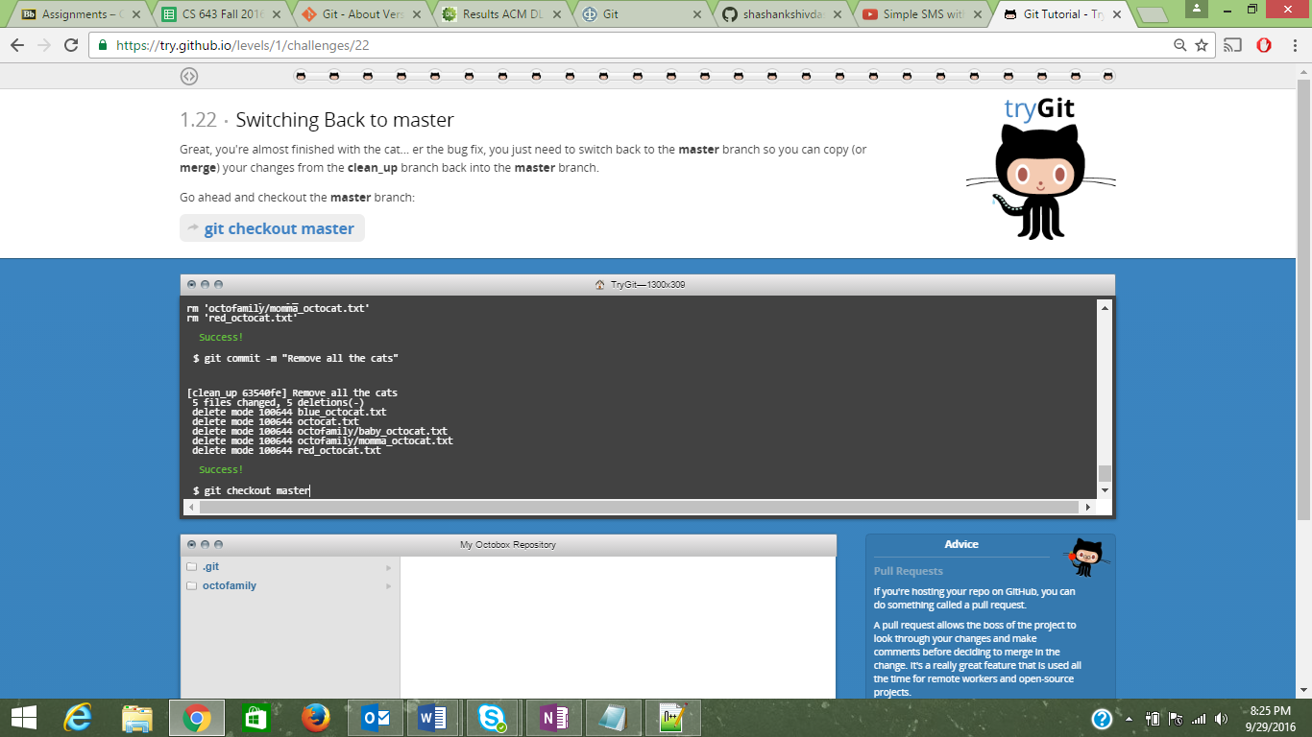

23)

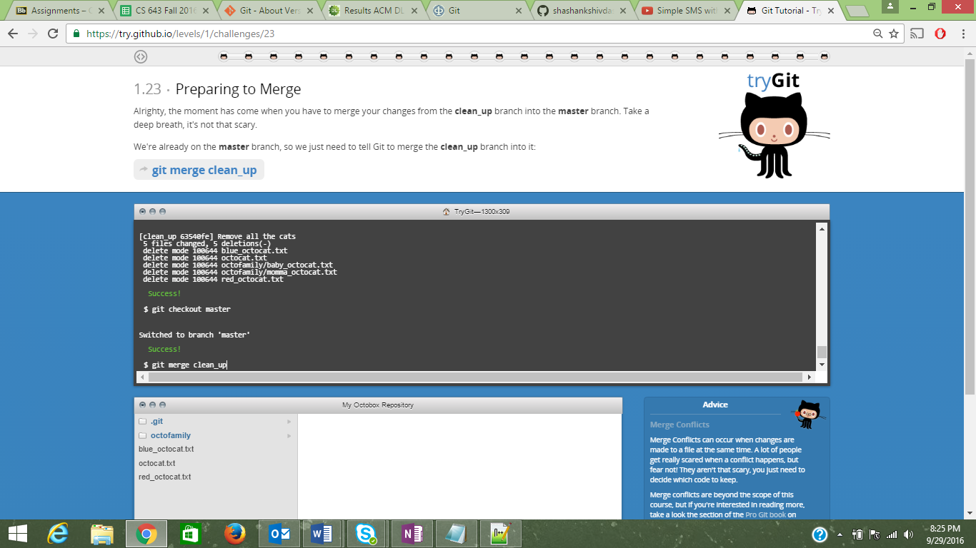

24)

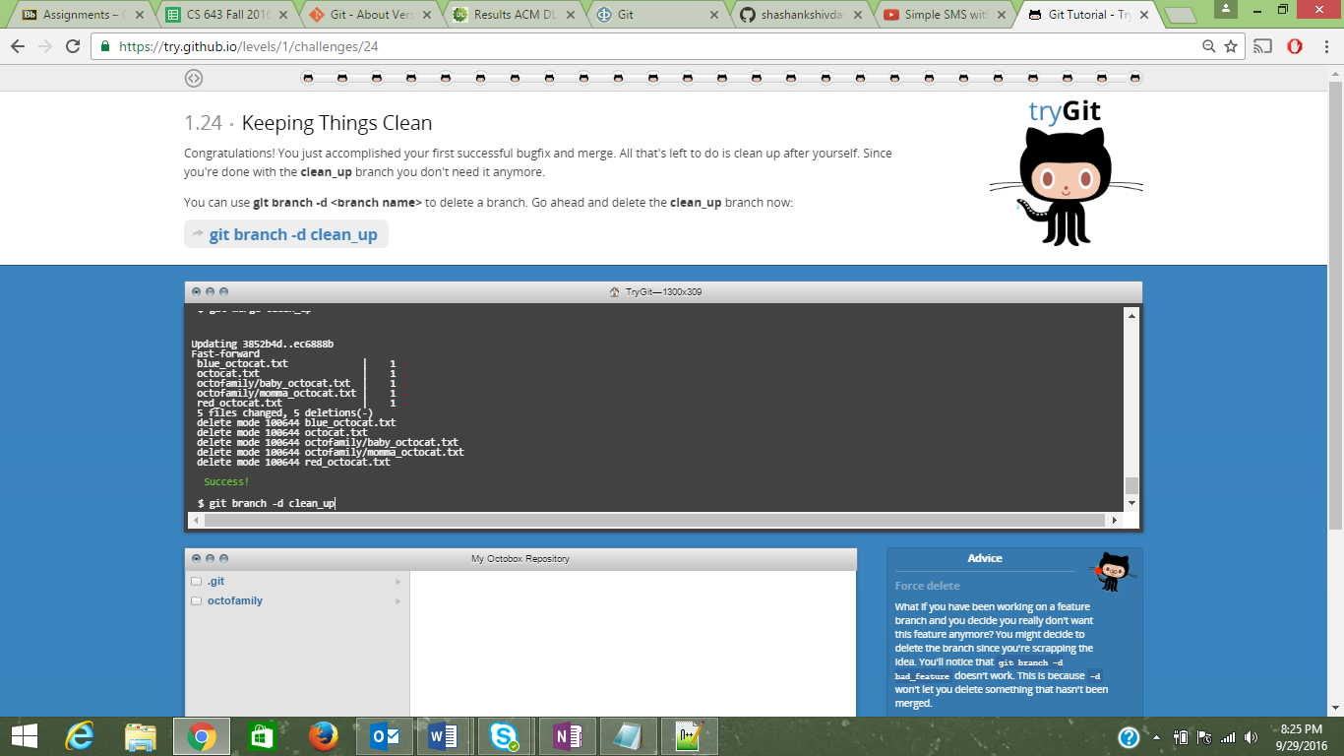

25)

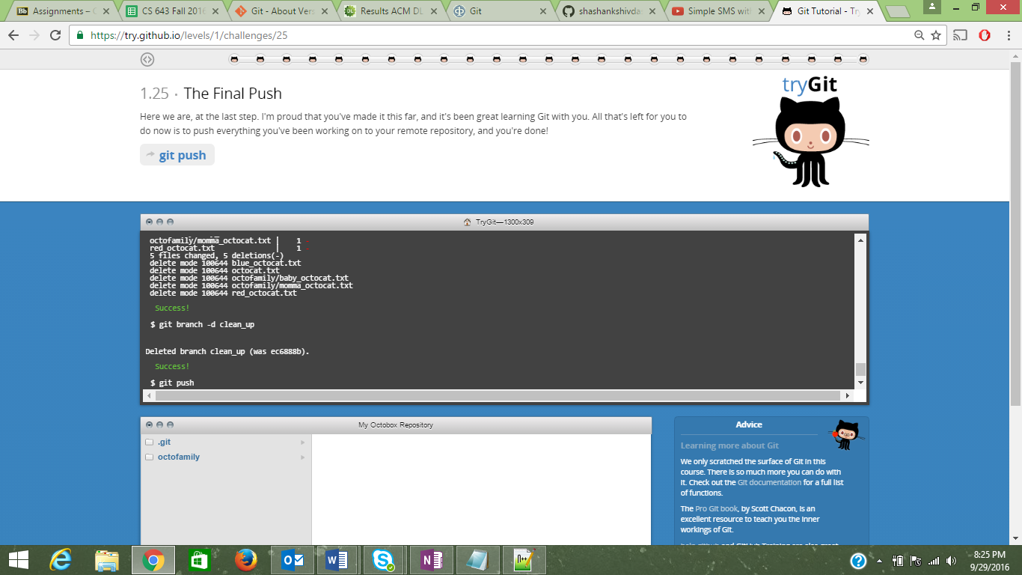

26)

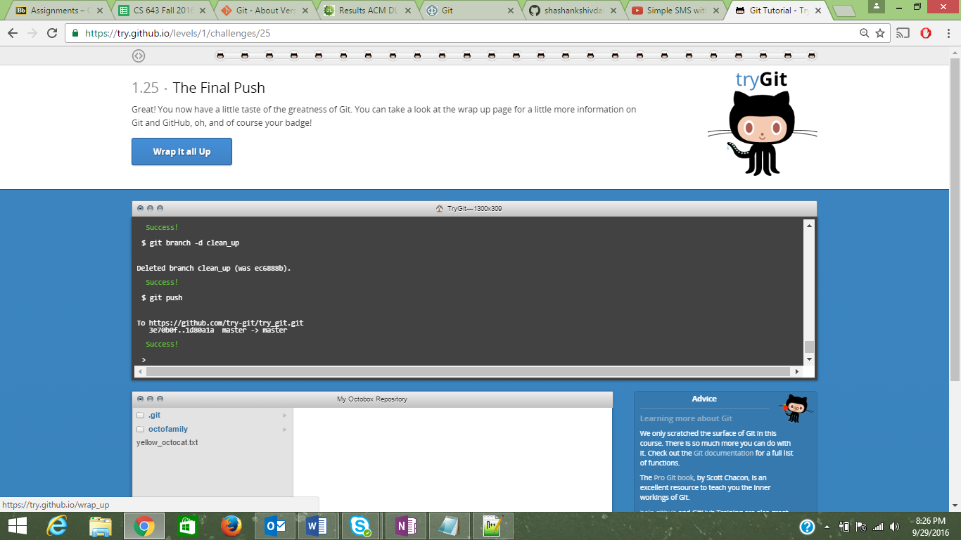

Following are the Terms explained in the context of Git:

**Repository**: It’s a data structure where Git stores all the data like the details of the Project, or a set of files through the complete course of time.  
  
**Commit**: It is used to capture the modifications/snapshots done in the repository.

**Push**: Push command is helpful in adding the commits which we perform on the local repository to a remote repository.

**Branch**: It lists out all the branches present and their tracking information in a shorter format or we can describe it as directed aliphatic chart of development.

**Fork**: Repository’s replica is called as fork. When we fork a repository, it gives us the leverage to make modifications freely without affecting the original project.

**Merge**: This command is used in joining two or more progress histories together.

**Clone**: When we use the clone command, it helps us to create an identical copy of the repository to a local machine.

**Pull**: We use the git pull command to pull the variations from the remote repository to the current repository.

**Pull request**: A Pull request is send to a remote repository wherein the maintainer would pull the changes from our repository to theirs.

**Update the Readme.md file in GitHub**:

Go to the <https://github.com/paceuniversity/courses>   
Click on the Readme.md File.  
Click on the Pencil icon on the top of ‘courses option’ in RHS.  
Add the relevant details (Name, Date and Time).  
Click on Propose changes.  
Create a Pull Request for the same.  
Once the author approves it by the Merge Request, The file is updated.